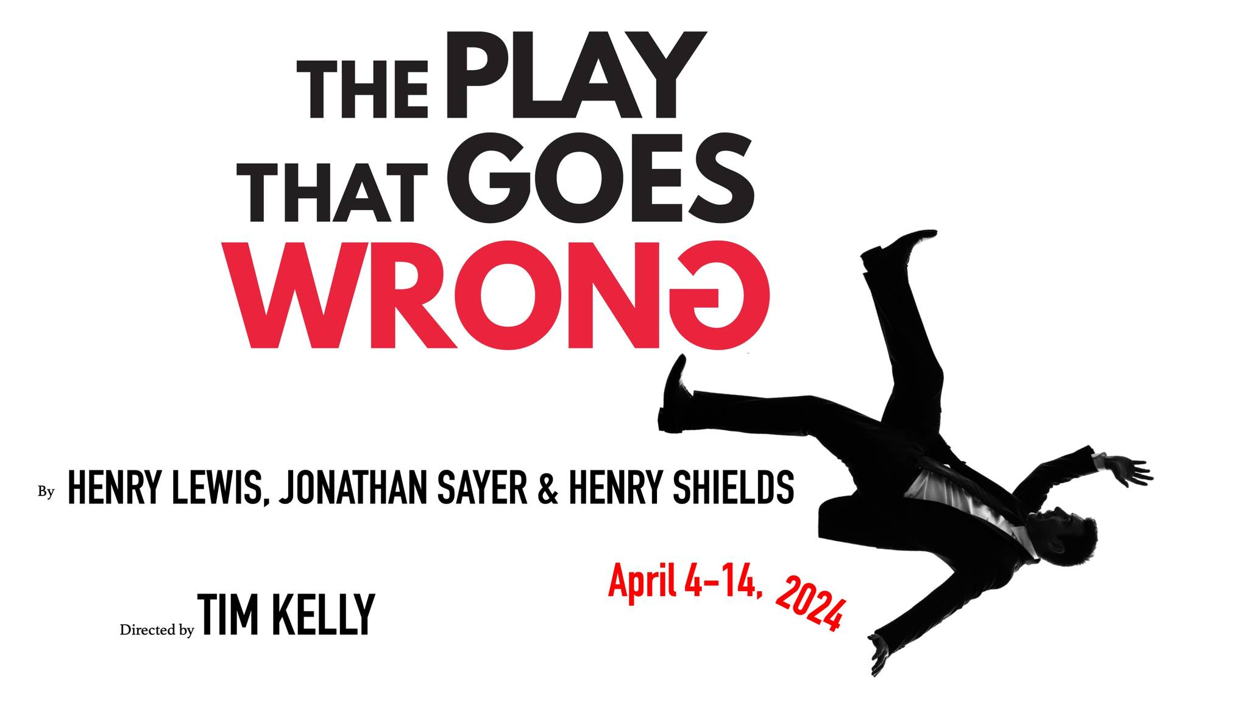
The Play That Goes Wrong, done right
Tim Kelly leads full-on production of disruptive British comedy hit
at Clayton Community Theatre April 4-14, 2024

Clayton Community Theatre (CCT - www.placeseveryone.org) continues its 25th season with The Play That Goes Wrong, by Henry Lewis, Henry Shields and Jonathan Sayer, directed by Tim Kelly.

PERFORMANCES: Thurs-Sun, April 4-14, 2024 (7:30 p.m. Thurs-Sat; 2:00 pm Sun) at Washington University South Campus Theatre, 6501 Clayton Rd, Clayton MO 63117.

TICKETS: $15-$25 (discounts for season tickets, group sales, seniors and students) - available via SimpleTix, or from CCT online at www.placeseveryone.org, or by phone at 314-721-9228. Financial assistance for this project has been provided by the Missouri Arts Council, a state agency.

PLEASE NOTE: 7:30 p.m. start time for evening performances.

REVIEWERS / MEMBERS OF THE PRESS: For additional materials, info and reviewer tickets, reach out to CCT media contacts Nathan Schroeder and Judith Rubin, media@placeseveryone.org; tel. 314-721-9228. Also please visit the CCT Media Resources page.

Full houses are expected for this play-within-a-play, a comic ensemble of blunders, mishaps, miscues, bungled lines and slapstick moments as Clayton Community Theatre continues its 25th season.
Bringing The Play That Goes Wrong (TPTGW) to Clayton Community Theatre (CCT) is a long-held ambition for Tim Kelly, Director and CCT Board Member, who saw the show on Broadway in 2017. Tim says, “This will be a CCT experience like no other, and I look forward to seeing the community turn out in force.” Tickets are selling quickly, with some performances already nearing audience capacity.
As they laugh (and laugh some more), audiences will gain heightened respect for the art and craft of theatre. Because while tickling patrons’ funnybones, TPTGW - written by Henry Lewis, Henry Shields and Jonathan Sayer - also builds awareness of the many things that can go wrong amid the intricacies of stage production.
In this ground-breaking – not to say leg-breaking – tour de force of slapstick satire, the timing, stunts, effects, set design and numerous surprise elements all come together in order to fall apart. The “fourth wall” is also fractured over and over. TPTGW is a hilarious spin on classic storytelling, with an endless string of visual, verbal and physical gags that never let up until the floor-shaking finale.
As the story goes, the amateur players of the Cornley University Society are endeavoring to put on a British “murder at the manor” mystery whodunit. Pretty much anything that can go wrong, does – and on every level, including the set itself. The traditional-seeming tableau looks like a Victorian manor house, but as experienced by the hapless characters in the play, it is more of a surprise parkour course. Regardless, the company valiantly and acrobatically strive to keep things going to the last scene.
To make everything “wrong” go right, producing TPTGW calls for challenging levels of stunt work and set building. At Clayton Community Theatre, Tim Kelly and his able team have embraced both and for many months have been deeply involved in the process of bringing a stellar TPTGW to St Louis audiences.
Tim is a millwright and member of the local carpenter’s union who works as a superintendent for a company doing maintenance work at General Motors. Outside of business hours, Tim is a community theatre superhero with long ties to the St. Louis theatre community. Longtime CCT Board member and director Sam Hack was his middle school and high school drama teacher, and drew him in to work on productions. In the past, Kelly directed Noises Off and Black Comedy for CCT and served as technical director for six years. He is one of three recent additions to the CCT Board, along with Jessica Johns Kelly and Rob Corbett.
“This production needs people with very distinct talents and skills,” says Tim. “Fight choreographer Jack Kalan’s expertise is helping everyone through the show’s many stunts and skirmishes. John Davidson has been working beside me to build the set, and his energy and problem solving have contributed greatly. Our team is simply magnificent.”
Even a Broadway or West End caliber theatre that boasts a full complement of rigging, lighting and tech elements undertakes significant challenges with a production of this kind in terms of scenics, blocking, cueing, coordination and timing. But smaller, regional theatres around the world – such as CCT - have eagerly embraced TPTGW and have devised their own solutions and created an open-source community to share tricks and methodologies.
Henry Lewis, Henry Shields and Jonathan Sayer, the original creators of “The Play That Goes Wrong,” first met at the London Academy of Music and Dramatic Art. Later, as roommates in West London, they cooked up TPTGW and under the banner of the Mischief Theatre Company have continued to expand their unique and zany brand of theatre culture.
“The Play That Goes Wrong” has run continuously in the London West End at the Duchess Theatre since 2014 and was distinguished with the 2015 Olivier Award for Best New Comedy. It was also a Broadway hit, running for more than a year at the Lyceum theater, produced there by Kevin McCollum and J.J. Abrams, and honored with a Tony Award.
“When Tim Kelly is this committed and passionate about a project, I know it’s time to get out of the way and let him create!” says Clayton Community Theatre President Marilyn Albert-Hack. “Tim has all the right answers, and this set is the most impressive I’ve ever seen! This production will be talked about for years. Come, see this play!”

The Play That Goes Wrong – Cast & Crew
Cast
ANNIE: Elle Klasing
TREVOR: Brad Kinzel
CHRIS: Jason Meyers
JONATHAN: Joey Franks
ROBERT: Jeff Kargus
DENNIS: Jeff Lovell
MAX: Michael Baird
SANDRA: Jennelle Gilreath Owens

Crew
Director: Tim Kelly
Assistant Director: Betsy Gasoske
Set Design/Technical Director: Tim Kelly
Sound Design: Jacob Baxley
Lighting Design: Nathan Schroeder
Costumer: Rob Corbett
Props: Jade Nolan-Davidson
Set Dressing: Rob Corbett
Fight Choreographer: Jack Kalan
Show Caller/Stage Manager: Miriam Whatley
Assistant Stage Manager: Betsy Gasoske
Light Board: Keith Kronemer
Sound Board: Dave Bornholdt
Box Office/Program: Ellen Schroeder
CCT President: Marilyn Albert-Hack
CCT Artistic Director: Sam Hack

Next up at Clayton Community Theatre:
Twelfth Night, by William Shakespeare, directed by Heather Sartin, July 11-21, 2024
All-female cast!
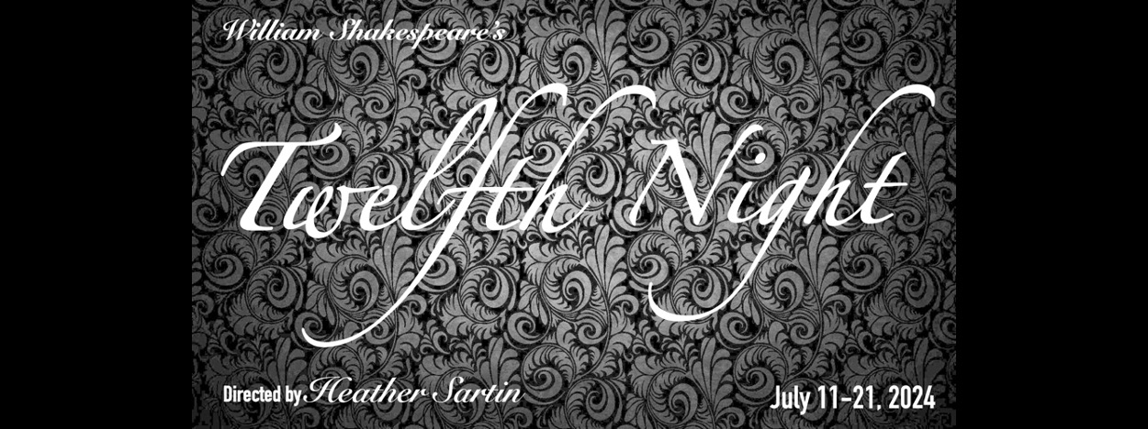

About Clayton Community Theatre
Clayton Community Theatre was founded in 1998. CCT’s purpose is to provide a vehicle for all members of our community to be involved in the production of top-quality live theatre. Through its annual productions and program of community outreach, CCT has involved hundreds of individuals in productions that have played to consistently enthusiastic reviews and crowded houses. CCT believes that our successful history as a theatre company has proven that there is an important place in our community for a volunteer theatre company that is open to all and driven by a commitment to excellence.
CCT productions take place in the Washington University South Campus Theatre, an outstanding 210-seat venue at 6501 Clayton Road with handicap accessibility, elevators, and a lighted parking lot. CCT operates on the Washington University campus as an independent community theatre company and is not affiliated with the Washington University Performing Arts Department.
Clayton Community Theatre is incorporated as a Missouri nonprofit corporation and is a 501(c)(3) tax-exempt organization. Membership in the organization is open to any interested individual. CCT receives financial assistance from the Missouri Arts Council, a state agency.

